Object Oriented Programming in basics

Object Oriented programming is a programming style that is associated with the concept of Class, Objects and various other concepts revovling around these two, like Inheritance, Polymorphism, Abstraction, Encapsulation etc.
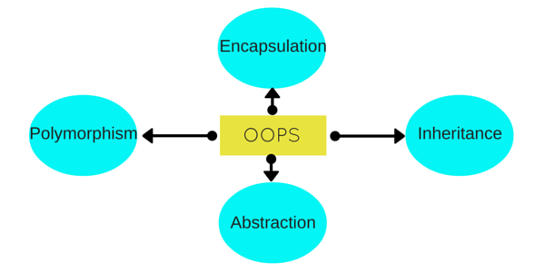
Let us try to understand a little about all these, through a simple example. Human Beings are living forms, broadly categorized into two types, Male and Female. Right? Its true. Every Human being(Male or Female) has two legs, two hands, two eyes, one nose, one heart etc. There are body parts that are common for Male and Female, but then there are some specific body parts, present in a Male which are not present in a Female, and some body parts present in Female but not in Males.
All Human Beings walk, eat, see, talk, hear etc. Now again, both Male and Female, performs some common functions, but there are some specifics to both, which is not valid for the other. For example : A Female can give birth, while a Male cannot, so this is only for the Female.
Human Anatomy is interesting, isn't it? But let's see how all this is related to C++ and OOPS. Here we will try to explain all the OOPS concepts through this example and later we will have the technical definitons for all this.

Class
Here we can take Human Being as a class. A class is a blueprint for any functional entity which defines its properties and its functions. Like Human Being, having body parts, and performing various actions.

Inheritance
Considering HumanBeing a class, which has properties like hands, legs, eyes etc, and functions like walk, talk, eat, see etc. Male and Female are also classes, but most of the properties and functions are included in HumanBeing, hence they can inherit everything from class HumanBeing using the concept of Inheritance.

Objects
My name is Abhishek, and I am an instance/object of class Male. When we say, Human Being, Male or Female, we just mean a kind, you, your friend, me we are the forms of these classes. We have a physical existence while a class is just a logical definition. We are the objects.

Abstraction
Abstraction means, showcasing only the required things to the outside workd while hiding the details. Continuing our example, Human Being's can talk, walk, hear, eat, but the details are hidden from the outside world. We can take our skin as the Abstraction factor in our case, hiding the inside mechanism.

Encapsulation
This concept is a little tricky to explain with our example. Our Legs are binded to help us walk. Our hands, help us hold things. This binding of the properties to functions is called Encapsulation.

Polymorphism
Polymorphism is a concept, which allows us to redefine the way something works, by either changing how it is done or by changing the parts using which it is done. Both the ways have different terms for them.
If we walk using our hands, and not legs, here we will change the parts used to perform something. Hence this is called Overloading.
And if there is a defined way of walking, but I wish to walk differently, but using my legs, like everyone else. Then I can walk like I want, this will be calles as Overriding.

