Introduction to Computer

Computer derives its name from the word Compute that means calculation. It can be said that Computer is a device used for calculation. Nowadays Computer is not only limited to computation, but also used for making phone calls, maintaining databases, listening songs, viewing movies etc,
so a more formal definition of Computer is
" it is an electronic device that processes or transforms data into useful information by executing a series of predefined instructions."
A computer is a device that can be instructed to carry out an arbitrary set of arithmetic or logical operations automatically. The ability of computers to follow a sequence of operations, called a program, make computers very applicable to a wide range of tasks. Such computers are used as control systems for a very wide variety of industrial and consumer devices. This includes simple special purpose devices like microwave ovens and remote controls, factory devices such as industrial robots and computer assisted design, but also in general purpose devices like personal computers and mobile devices such as smartphones. The Internet is run on computers and it connects millions of other computers.Since ancient times, simple manual devices like the abacus aided people in doing calculations. Early in the Industrial Revolution, some mechanical devices were built to automate long tedious tasks, such as guiding patterns for looms. More sophisticated electrical machines did specialized analog calculations in the early 20th century. The first digital electronic calculating machines were developed during World War II. The speed, power, and versatility of computers has increased continuously and dramatically since then. Conventionally, a modern computer consists of at least one processing element, typically a central processing unit (CPU), and some form of memory. The processing element carries out arithmetic and logical operations, and a sequencing and control unit can change the order of operations in response to stored information. Peripheral devices include input devices (keyboards, mice, joystick, etc.), output devices (monitor screens, printers, etc.), and input/output devices that perform both functions (e.g., the 2000s-era touchscreen). Peripheral devices allow information to be retrieved from an external source and they enable the result of During World War II, the British at Bletchley Park achieved a number of successes at breaking encrypted German military communications. The German encryption machine, Enigma, was first attacked with the help of the electro-mechanical bombes. To crack the more sophisticated German Lorenz SZ 40/42 machine, used for high-level Army communications, Max Newman and his colleagues commissioned Flowers to build the Colossus.[28] He spent eleven months from early February 1943 designing and building the first Colossus.[29] After a functional test in December 1943, Colossus was shipped to Bletchley Park, where it was delivered on 18 January 1944[30] and attacked its first message on 5 February.[28]

Colossus was the world's first electronic digital programmable computer.[18] It used a large number of valves (vacuum tubes). It had paper-tape input and was capable of being configured to perform a variety of boolean logical operations on its data, but it was not Turing-complete. Nine Mk II Colossi were built (The Mk I was converted to a Mk II making ten machines in total). Colossus Mark I contained 1500 thermionic valves (tubes), but Mark II with 2400 valves, was both 5 times faster and simpler to operate than Mark 1, greatly speeding the decoding process.[31][32]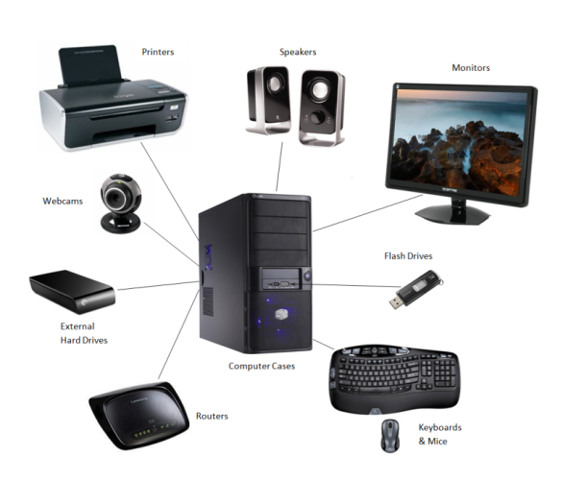operations to be saved and retrieved.

