Loop types
In any programming language, loops are used to execute a set of statements repeatedly until a particular condition is satisfied.

How it works
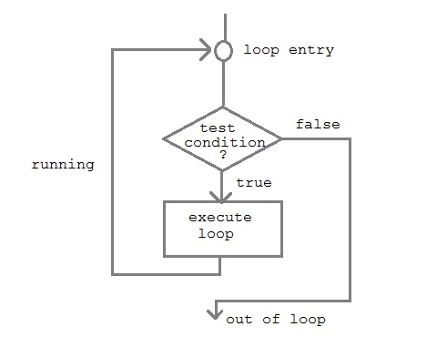
A sequence of statement is executed until a specified condition is true. This sequence of statement to be executed is kept inside the curly braces { } known as loop body. After every execution of loop body, condition is checked, and if it is found to be true the loop body is executed again. When condition check comes out to be false, the loop body will not be executed.

There are 3 type of loops in C++ language
- while loop
- for loop
- do-while loop

while loop
while loop can be address as an entry control loop. It is completed in 3 steps.
- Variable initialization.( e.g int x=0; )
- condition( e.g while( x<=10) )
- Variable increment or decrement ( x++ or x-- or x=x+2 )
Syntax :
variable initialization ;
while (condition)
{
statements ;
variable increment or decrement ;
}

for loop
for loop is used to execute a set of statement repeatedly until a particular condition is satisfied. we can say it an open ended loop. General format is,
for(initialization; condition ; increment/decrement)
{
statement-block;
}
In for loop we have exactly two semicolons, one after initialization and second after condition. In this loop we can have more than one initialization or increment/decrement, separated using comma operator. for loop can have only one condition.

Nested for loop
We can also have nested for loop, i.e one for loop inside another for loop. Basic syntax is,
for(initialization; condition; increment/decrement)
{
for(initialization; condition; increment/decrement)
{
statement ;
}
}

do while loop
In some situations it is necessary to execute body of the loop before testing the condition. Such situations can be handled with the help of do-while loop. do statement evaluates the body of the loop first and at the end, the condition is checked using while statement. General format of do-while loop is,
do
{
....
.....
}
while(condition);

Jumping out of loop
Sometimes, while executing a loop, it becomes necessary to skip a part of the loop or to leave the loop as soon as certain condition becocmes true, that is jump out of loop. C language allows jumping from one statement to another within a loop as well as jumping out of the loop.

1) break statement
When break statement is encountered inside a loop, the loop is immediately exited and the program continues with the statement immediately following the loop.

2) continue statement
It causes the control to go directly to the test-condition and then continue the loop process. On encountering continue, cursor leave the current cycle of loop, and starts with the next cycle.

